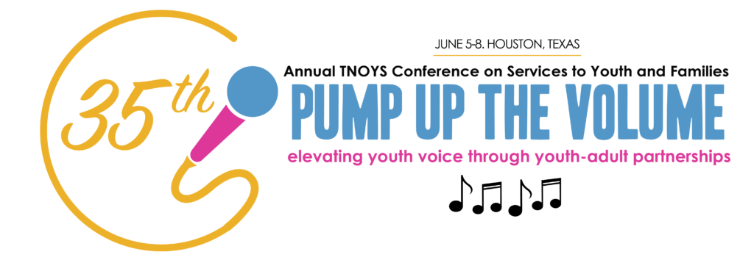

Become a youth presenter at TNOYS’ annual conference!
At the Texas Network of Youth Services (TNOYS) annual conference, youth service workers, administrators, youth, and others come together to have fun while learning about how to create the best future for youth and families. If you are a youth (up to 24 years old) with valuable experience to share and a desire to gain presentation skills, we encourage you to become a presenter at this year’s conference!
We are currently looking for youth presenters and youth/ adult presenter teams to speak to youth about growing their leadership skills, to adults about how to build partnerships with youth, and to both audiences about a variety of other topics!
Follow this link to find a list of priority topics we are looking for, the application to become a presenter, and other great information about our conference:
tnoys.org/2018-annual-conference/call-for-presenters/
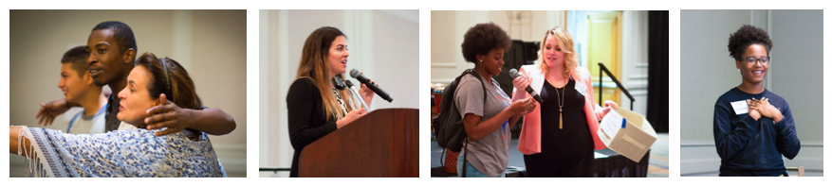

If you are interested in becoming a presenter, contact [NAME] at [email@email.org] for help filling out an application.
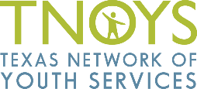
For all other questions, please contact Lara O’Toole at Lotoole@tnoys.org

