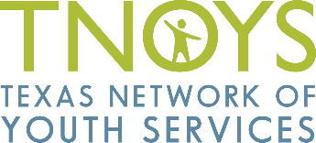
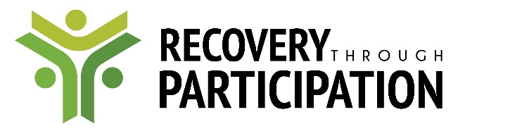

2017 Training and Collaborative Consultation Series

TNOYS and our partners will be offering FREE training with CEUs as well as individualized consultation to help programs strengthen their youth engagement. Each training will be customized based on your input.
Contact Lara O’Toole LOToole@tnoys.org or visit www.tnoys.org/recovery-through-participation to learn more.

Wednesday, May 17th - Foundations of Youth Engagement, A Trauma-Informed Best Practice
At this session, we will define and review core components and the research basis behind the use of positive youth development, trauma-informed care, and youth-adult partnerships. We will discuss the links between theory and practice, especially the specific ways in which youth engagement strengthens program outcomes and organizational culture while supporting youth in their recovery from trauma. We will also spend time on strategies for building all youth-adult partnerships and the range of ways providers can engage youth. This includes a conversation with youth services providers who are already engaging youth and the opportunity to draft an action plan and consider your program’s specific goals and challenges.

Wednesday, June 7th
Continuum of Youth Engagement Part 1: Trauma-Informed Ways to Gather Youth Input
This session will cover the nuts and bolts best practices of one-time or ad hoc youth engagement as well as how these practices support trauma-informed care. This includes using and improving client surveys and feedback forms; conducting focus groups to gather input; co-presenting or co-facilitating with youth who are currently or formerly in services; and more. As with all trainings in this series, we will customize the training to your topics of interest and spend time discussing your specific experiences and goals as well as hear from local providers who have had success with these methods of engagement.

Wednesday, July 12th
Continuum of Youth Engagement Part 2: Youth-Driven Programming, Boards, and Evaluation
This session will cover the nuts and bolts best practices of ongoing youth engagement and how these are the building blocks of trauma-informed organizations. This includes forming and sustaining youth advisory groups; adding youth in meaningful ways to boards and councils; giving youth meaningful roles in evaluation, employee hiring, or communications; and more. As always, we will hear from providers with direct experience with ongoing youth engagement, ground the discussion in the research, and spend time on your goals and questions around creating opportunities for youth or strengthening existing efforts.

Wednesday, August 9th
Continuum of Youth Engagement Part 3: Inspiring Recovery, Developing Peer Support Opportunities
This session will cover the nuts, bolts, theory, and research behind including youth in peer support roles, including paid staff positions. There are a number of considerations around organizational capacity and culture to discuss to ensure that youth on staff feel valued, mentored, and supported. We will also review the incredible potential and impact that youth in peer roles can have on other youth being served. Providers with experience in hiring or supervising youth peers – and youth who have worked in peer support roles – will join us for an honest discussion of their successes and challenges along the way.

Wednesday, September 13th (tentative) – A Reception to Pause and Celebrate
TNOYS invites all project partners and supporters to come together and celebrate our collective successes this year in trauma-informed youth engagement as well as to help us kick off a youth peer counseling pilot!

